INTELLECTUAL PROPERTY INTRODUCTION CHART

 | Patent | TRade Secret | Copyright | Trademark | TRade Dress
Example |  | 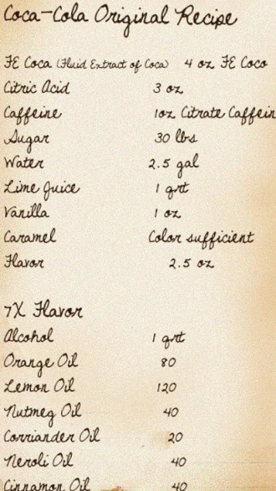
What Is Protected | An invention in any of 3 categories:  Utility  Plant  Design | Confidential business know-how (e.g., formulas, recipes, methods, processes) | Writing, computer software code, music, art, architecture, graphic design | Basically, your brand: a word/phrase, slogan, logo or visual symbol (trade dress) that supports a brand | Product packaging or design
Criteria for Protection | New  Non-obvious  Useful (for a utility patent)  Non-functional (for a design patent) | Must be kept secret | Original (new)  Creative  “Fixed in a tangible medium of expression” | Distinctive – not generic or descriptive  Unambiguously identifies source of product or service | Distinctive (in the consumer’s mind, packaging or design = source of product)  Non-functional
HOW to REGISTER for protection
Period of Protection | 20 years from filing of application (14 years for a design patent) | Until no longer secret | In most cases, 70 years from the death of the creator | Until no longer used | Until no longer used

